# **Chapter 4**

## **RESULTS AND DISCUSSION**

This chapter is the presentation of the development result and discussion of the identified problems and also provides the system procedures and diagrams such as fishbone diagrams, functional decomposition diagrams, context diagrams, data flow diagrams, business process diagrams, use case diagrams different tests made by the researchers provide a reference that can be used in the future researchers.

### **Planning**

The researchers addressed the identified issues that need to be resolved during this phase, as well as the procedures that must be followed to provide specific solutions to the challenges faced by the institution and target customers. In this phase, researchers interviewed the barangay captain and secretary to define the existing problem occurring in terms of barangay retrieval and request in the barangay.

#### **Identified Problems**

Table 7 depicts the problems identified during our interviews with barangay officials, specifically the barangay captain and secretary of the barangay Paloyon Oriental. Through this action, we were able to construct the specific problem and offer a solution to the challenges with barangay retrieval and request that were encountered in the barangay. Based on our interview barangay officials use manual encoding for certificates requested by the residents. They used folders and papers in managing files and records of the barangay resulting in much space consumed and a slow process of searching for the specific data. Also, some records were not maintained to be kept safely because of unexpected events that may destroy the records of barangay.

Table 7

**LEVEL OF FUNCTIONALITY USING BLACK BOX TEST**

|  |  |
| --- | --- |
| **Identified Problems** | **Description** |
| Time Consuming | The manual process of managing the documents is time-consuming |
| File confidentiality | Lack of protection could cause the evaluation’s files to leak. |
| High risk of COVID-19 contacts | It’s very hard for many to go to a barangay to request documents because of pandemic. |
| Lacks Barangay Personnel | The availability of their personnel is not that present all the time to manage the documents. |
| Inaccuracy in Document Processing | Because of their lack of personnel, there are lots of documents that can’t process on time and it is delayed for the resident/requestor. |

#### **Proposed Solutions**

The researchers proposed an automated Barangay Management System with SMS Notification to address the aforementioned issues. Barangay personnel administrators will be able to electronically create and maintain records, announcements, reports, and services with the help of this technological adaptation. The method will shorten the time it takes to respond to residents’ needed requirements. The aforementioned system will get rid of all the issues and mistakes that came up throughout the manual process. The method will do away with the necessity for residents to interact with barangay duty officers in person. The system's deployment will enhance the overall services the barangay offers to its residents.

The researchers identified a step-by-step technique for this phase that will express the inputs, outputs, and actions that happen during this phase. The researchers examined the operational feasibility using the Fishbone Diagram and the schedule feasibility using the Gantt chart.

#### **Operational Feasibility**

Operational feasibility is a metric used to assess how successfully a proposed system addresses the issues, seizes opportunities identified during scope definition, and satisfies requirements found during the requirements analysis stage of system development. This is a presentation of the Web-Based Management System with SMS Notification of Barangay Paloyon Oriental's operational viability to assist and carry out the necessary tasks. It features a functional decomposition diagram and a fishbone diagram. The system's potential causes and effects are shown in this feasibility study, along with a functional decomposition diagram of the system's operation. It can be applied to help organize brainstorming sessions. It categorizes concepts immediately into useful groups.

##### ***Fishbone Diagram***

This figure aids in identifying all the symptoms of any business problem by dissecting the causes and underlying factors of a single issue.

Machine

Information

Out dated Software

Need to monitor the client

Insufficient Storage

Mistaken information given

Manual Process of Documents Record for Barangay Paloyon Oriental

Log in error

Form not completely fill up

Time Consuming

Data loss

Requested delay

Security

Process

Figure 2: **Fishbone Diagram**

A Fishbone diagram helps to figure out the reason and possible causes and effects of the system. The cause of the overall problem is determined by the arrows that represent the bones in the fishbone diagram, while the effect is determined by the head of the diagram. This diagram supports the development to be more productive for admin and client using the system. The target of using a fishbone diagram is to lessen work time for the user of the system development.

##### ***Functional Decomposition Diagram***

Functional decomposition diagrams, commonly referred to as hierarchy charts, are a tool used to show how a system is broken down. It demonstrated the breakdown of the high-level function and process into its more intricate and detailed parts. The web-based management system's processes and procedures are divided into smaller functions in Figure 3. The graphic served as a plan for categorizing the web application's component sections.

WEB-BASED MANAGEMENT SYSTEM WITH SMS NOTIFICATION OF BARANGAY PALOYON ORIENTAL

Resident

Administrator

Request Documents

Log In

Activity Logs

SMS

Manage Certificates

Manage Report

Blotter Complaints

Disseminate Updates, Announcements

View Logs

Check Request

Upload Document

View Request

View Document

Approve Request

Delete Document

Download Document

Generate Request

Print Document

Print Document

Figure 3: **Functional Decomposition Diagram**

This presentation shows the functional decomposition diagram that focuses on how the overall functionality is developed and its interaction between various components. Shows the breakdown of specific components that are present in this system, specifically this is to know what are the functions under each of every component, serves as a chart whenever problems during the process will occur for easy detections of what component fails and resolving it at a time, it is the guide on where to begin during the debugging process and shows the directions and connections of every component of the system.

**Schedule Feasibility**

This illustrates how quickly the system was developed. The likelihood that a project will be finished by the anticipated due date and within the allotted time frame is known as timetable feasibility. A project's schedule feasibility is rated highly if there is a good chance it will be finished on time. Each task has a deadline associated with it. Activities include from the data gathering phase up to final state project development. As a result, the activities are being documented in order to evaluate the project's status and progress. Each month's project action plan is indicated.

##### ***Gantt Chart***

To make the project done in a specific time frame and make it to its deadline, and get through the different series of system tests that will attest to the functionality of the system, the researchers made a Gantt chart to manage the given time of the project preparation.

One of the most popular tool for monitoring project schedules is the Gantt chart. A Gantt chart, which is widely used in project management, is one of the most popular and useful methods of displaying activities (tasks or events) against time. The chart has a list of the activities on the left and a time scale along the top. Each activity is represented by a bar, with the position and length of the bar reflecting the activity's start, duration, and end dates [].

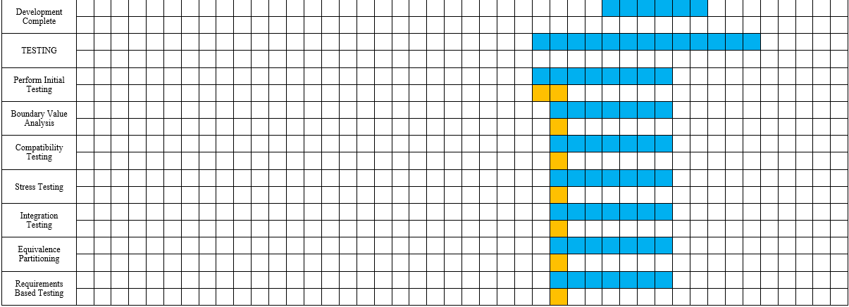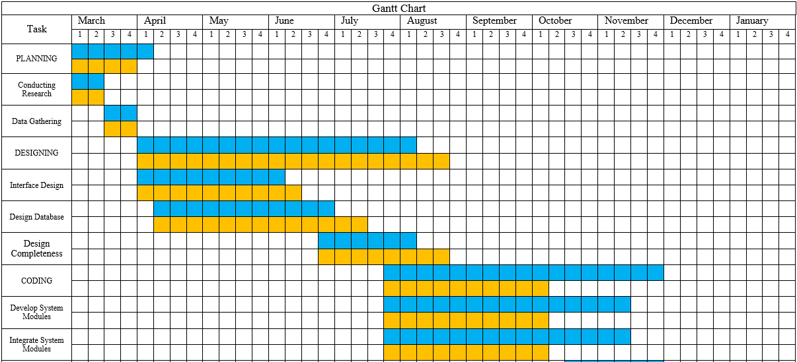

Figure 4: **Gantt Chart**

The researchers used the Gantt chart above to show how the given tasks and dates were completed. From the submission of the title, data collection such as interviews and surveys, planning, revising chapters, development process including system design and coding, and debugging were checked by the capstone adviser before the Pre-Oral and Final Defense. Upon development of the system, the researchers found it simple to meet the deadlines for completing the overall preparation as it serves as a guide for improvement of Barangay Management System with SMS Notification of Paloyon Oriental. The Gantt chart was created to maintain the target timeline schedule, which was monitored on a daily, weekly, and monthly basis from title confirmation to implementation and document compilation.

#### **Requirements Modeling**

The input, process, output, performance, and control requirements were incorporated into the requirements modeling used to create the developed system. To better comprehend the process of the system, object modeling was also used to explain the actions conducted after system creation. These are acquired from every party that is anticipated to utilize, maintain, or benefit from the solution, and they are grouped into several categories including Context Diagram and Data Flow Diagram.

***Input.*** It denoted the system's foundation or basic growth throughout the input phase. The researchers envisioned developing a system that would precisely record the transaction, limit the usage of paper, and function as a long-term arrangement.

***Process.*** During the processing phase, it transformed the data that had been entered into usable information. It was the idea of how the researcher built the system. Along with this, the coding stage began, in which the researcher broke down and began coding. After coding, testing started right away, which helped the researcher figure out the full range of the system's needs. The administrator can then handle it.

***Output.*** It is the method of presenting the system's outcome after a thorough review of the process. It represented the project's final output after a protracted production process. The system can simply print financial reports and other certificates as well as display them on the screen.

***Performance.*** As long as there is one admin to maintain the system either the barangay captain or secretary, the system must accommodate several online users at once. Six days a week, the system must be up and running.

***Control.*** The system needs login security to be able to manage it by authorized personnel only. Only the admin has access to the list of residents, the list of requesters, and the data that the requesters have provided.

#### **Data and Process Modeling**

The process of developing a data model for an information system using certain formal procedures is known as data modeling. This section of the project demonstrates the use of graphic techniques to describe the system's information. The proponents used this tool to construct the system architecture, the context diagram, and the data flow diagram that are shown below. This serves as a model for the process that was shown during the system's improvement, making it easy to understand and make sense of the stream and procedure for each level of project development.

##### ***Context Diagram***

The context diagram is used to determine the context and limits of the system to be modelled, such as what is inside and outside the system and how the system interacts with these other entities. A context diagram, also known as a level 0 data-flow diagram, is used to describe and illustrate the software system's boundaries. It locates information flows between the system and external entities

Request Documents

Manage Report

Resident

Manage Certificates

WEB-BASED MANAGEMENT SYSTEM WITH SMS NOTIFICATION OF BARANGAY PALOYON ORIENTAL

Blotter Complaints

Login

Activity Logs

SMS

Admin

Figure 5: **Context Diagram**

The context diagram shows how data enters and out as well as how administrators and residents exchange data. System function has a limited access both for admin and resident which admin can access all of the data information for the barangay official data and resident data information.

##### ***Data Flow Diagram***

The process or system's information flow is depicted in a data flow diagram. It contains the numerous sub processes the data flows through, data inputs and outputs, and data stores. Standardized symbols and terminology are used to construct DFDs in order to define diverse entities and their relationships.

Login

1.0

1

Barangay Official Table

Barangay Official Info

Barangay Official Detail

Admin

Approval

Manage Reports

2.0

Compilation of Reports Info

2

Files Table

Compilations of Reports Detail

Request Info

Request Detail

Manage Request

3.0

Request Info

3

Request Certificates Table

Request Detail

Residents

Blotter Detail

Blotter Reports Info

Manage Blotter Reports

4.0

Blotter Detail

Blotter Reports Info

4

Blotters Table

Manage Message

5.0

Message Info

5

Message Table

Message Detail

Manage Activity Logs

6.0

Activity Logs Info

6

Activity Logs Table

Activity Logs Detail

Figure 6: **Data Flow Diagram Level 0**

Figure 6 presents the level 0 data flow of the admin and also the input and output of every module and activity flow of data within the system.

2.0

Manage Reports

Reports Detail

Upload

2.1

Reports Detail

Upload Detail

Upload Detail

2.2

View

Reports Detail

View Detail

View Detail

Reports Detail

Reports Detail

Reports Detail

Admin (Barangay Captain & Secretary)

2.3

Delete

Files Table

2

Delete Detail

Delete Detail

Reports Detail

Reports Detail

2.5

Download

2.4

Print

Download Detail

Download Detail

Reports Detail

Reports Detail

Print Detail

Print Detail

Figure 7: **Data Flow Diagram Level 1- Manage Reports**

The figure 7 presents the level 1 data flow of the diagram for the manage reports and also the procedures, process and functions of the system inside the data modules.

This diagram shows the flow of the system on how the process of data information and function. That will establish the proper data flow for the input and output processes and to determine what are functions of the system in every level of diagram. It is a simple illustration on what connection and relationship of all system function we have. In input and output flow to a data include information and operation that can be add, delete, and edit the data information.

3.0

Manage Request

Request Detail

Request Detail

Resident

3.1

Request

Request Detail

Request Detail

View

3.2

View Request

View Request

Request Detail

Request Detail

Admin (Barangay Captain & Secretary)

3.3

Delete

3

Request Certificate Table

Delete Request

Delete Request

Print Request

Print Request

3.4

Print

Request Detail

Request Detail

Figure 8: **Data Flow Diagram Level 1- Manage Requests**

Figure 8 depicts the level 1 data flow diagram for managing requests, as well as the system's procedures, processes, and functions within the data modules.

In this diagram, the resident can only request a certificate of residency, barangay clearance, or certificate of indigency, which will be posted in the database's files table. While the admin is in charge of the manage requests module's view, delete, and print functions. The admin, who is also the barangay captain and secretary, will first approve the requested certificate, then check the payment option (cash on pick up or gcash), and if all of the necessary information is already accurate, the document will be processed and printed. The request, on the other hand, will not be processed if the requestor is not a registered resident, or does not have a record in the database, and if the admin does not approve the requested transaction.

4.0

Manage Blotter Report

Blotter Detail

Blotter Detail

Resident

4.1

Report

Blotter Detail

Blotter Detail

View

4.2

View Blotter

View Blotter

Blotter Detail

Blotter Detail

Admin (Barangay Captain & Secretary)

4.3

Delete

4

Blotters Table

Delete Blotter

Delete Blotter

Generate Letter Print

Print Blotter

Print Blotter

4.4

Blotter Detail

Blotter Detail

Figure 9: **Data Flow Diagram Level 1- Manage Blotter Report**

Figure 9 depicts the level 1 data flow diagram for managing blotter report, as well as the system's procedures, processes, and functions within the data modules.

In this diagram, the resident can only report a blotter if he/she experiences abuse within the circle of barangay. The admin will only approve the report if the one who reports is a legal resident in the barangay and has a piece of evidence to show the abuse. They are also in charge of managing the blotter reports module with specific functions like viewing, deleting, and printing the generated letter. If the admin approves the blotter report from the resident, then the barangay officials will contact the one who reports the abuse and should cooperate with barangay officials. If barangay officials and the council cannot handle the problem this will go through the help of the city police officers.

6.0

Manage Activity Logs

Activity Logs Detail

6

Activity Logs Table

View Activity Logs

Admin

6.1

View

Figure 10: **Data Flow Diagram Level 1- Manage Activity Logs**

Figure 10 depicts the level 1 data flow diagram for managing activity logs, as well as the system's procedures, processes, and functions within the data modules. In this diagram, the module is only present in admin side, the admin is the only one who can check and view the events/ changes happened within the admin dashboard.

***Use Case Diagram***

The use case diagram is a primary form of how someone who implements that process or system in reality will achieve a goal. Although it frequently refers to software systems, it can also be used to describe any process.

A use case is a methodology used in system analysis to identify, clarify and organize system requirements. The use case is made up of a set of possible sequences of interactions between systems and users in a particular environment and related to a particular goal [6].

This diagram is a type of behavioral UML diagram that is commonly used to analyze various systems. They make it possible to visualize the various types of roles in a system as well as how those roles interact with the system. This is used to collect system usage requirements. Depending on your needs, you can use this data in a variety of ways [].

Web-Based Management System with SMS Notification of Barangay Paloyon Oriental

Delete

View

Upload

Download



Print

Compilation of Reports

View

Activity Logs

SMS

View

Delete

Print



Request Certificates

Report Blotter

Residents

Delete

View

Print

Figure 9: **Use Case Diagram**

This section shows all activity of admin and resident base on the privileges of every user of the proposed system. The main user of the system is admin that can be view/update/delete information, activity log, add resident, and add events.

##### ***Sequence Diagram***

The sequence diagram is used primarily to show the interactions between objects in the sequential order that those interactions occur. Much like the class diagram, developers typically think sequence diagrams were meant exclusively for them. However, an organization's business staff can find sequence diagrams useful to communicate how the business currently works by showing how various business objects interact. Besides documenting an organization's current affairs, a business-level sequence diagram can be used as a requirements document to communicate requirements for a future system implementation [7].

Resident

Admin

System

Request Documents/ Report A Blotter

STORES INFORMATION

LOGIN

VIEW REQUEST DOCUMENTS

DISPLAY OUTPUT

STORES INFORMATION

BARANGAY MEMBER?

NO

YES

SEND A NOTIFICATION TO THE RESIDENT VIA SMS

PROCESS THE DOCUMENTS DEPENDS ON PAYMENT OPTIONS

Figure 10: **Sequence Diagram**

This diagram depicts the sequential event of how the system process from requesting certificates on the client side to the administrator approving the requested documents. The actions in the process are performed from left to right.

##### ***Risk Assessment Analysis***

Risk Assessment Analysis were conducted and it is an important part in preparation for potential issues that may occur within the project development. There are possible risks that were identified that could negatively affect the success of the developing system.

While developing the system, researchers encountered some of the risk such as management (i.e communication problems), technical, personal (i.e lack of computer literacy), other constraints including poor connectivity and the pandemic that affected group communication, lack of project management expertise due to inexperience and other risk those identified risks may affect both the developers or the researchers and the uses of the system.

### **Design**

The proponents concentrated on the planned system's architecture, structure, and requirements that they could introduce. Requirement modeling, data and process modeling, object modeling, output and user interface design, data design, and system architecture are all included in this section's specification of requirements. The researchers determine that the system flow, functions, process, and procedures are very simple to comprehend.

##### ***Output and User-Interface Design***

This section demonstrates the proposed system's various input and output designs. The designed interface is shown below.

##### **Data Design**

Early in the development cycle, data design focuses on determining customer demands and necessary functionality, documenting requirements, then moving on to design synthesis and system validation while taking into account the larger issue composed of: Operations. Performance. Integrate and test.

###### ***Entity Relationship Diagram***

##### **System Architecture**

The conceptual model that describes a system's structure, behavior, and other aspects is discussed in this section. The researchers will discuss the system's network model and structure as well as how the system handles security-related challenges. The justification for the system's architecture and behaviors is strengthened by this.

###### ***Network Model***

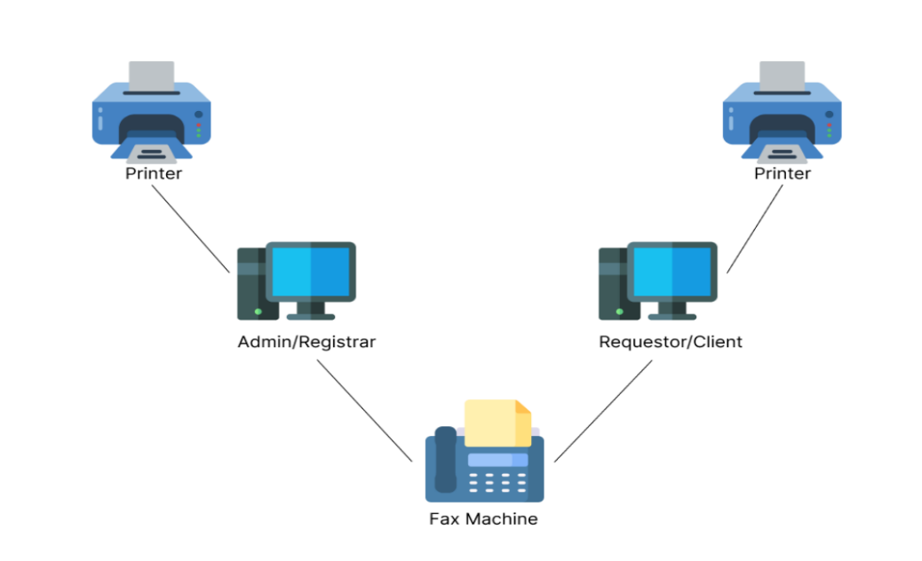Objects and their relationships can be represented in a database using a network model, which was created as a flexible method. The schema of the network model, which is regarded as a graph with relationship types as arcs and object types as nodes, is one of its distinctive features.

Figure 1: **Network Model**

Figure [] shows the network model of Web-Based Management System with SMS Notification of Barangay Paloyon Oriental. It is intended to describe the feature of the system and their interactions in a flexible manner. This shows how each components is connected wherein if one is missing it will not function properly.

###### ***Network Topology***

The configuration of a network, or its topology, includes a physical or logical description of how links and nodes are structured in relation to one another. Network topology describes how different nodes, devices, and connections are logically or physically structured in relation to one another on your network.

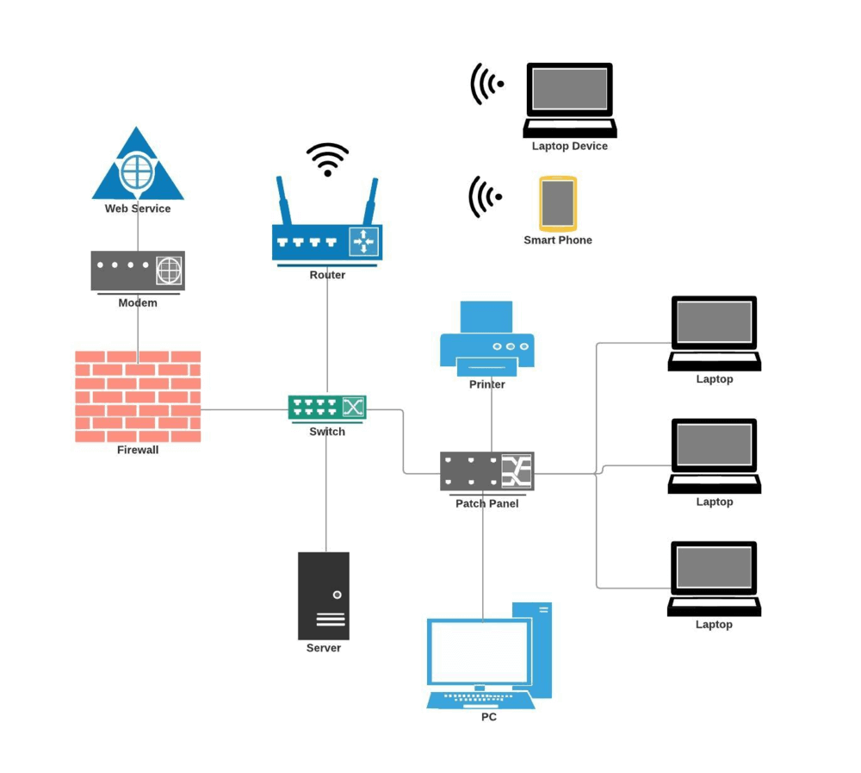

Figure 1: **Network Topology**

Figure [] shows the network topology of the system “Web-Based Management System with SMS Notification of Barangay Paloyon Oriental” that is to allow the administrator to view the physical network layout of those connected devices. It is very useful to understand how devices were connected to each other.

###### **Security**

One of the qualities a system must possess is security. Threats and attacks are prevented by having strong system security. A system with strong security can protect itself from potential attackers who may target the system's database or attempt physical intrusion. Only the primary user will be granted access to and use of the proposed system. To secure the system data, the admin must set up an account and password on the login form.

Since security is crucial in every system, ours will safeguard all the inhabitants' private records and files. The creators will offer an automatic backup in the event that the system was unintentionally deleted or lost. Depending on the user's needs, regular system file backups are possible.

It is crucial to have good system security when developing the Web-Based Management System with SMS Notification of Barangay Paloyon Oriental because it prevents potential hackers from using the system without authorization and avoids data manipulation from databases without the knowledge of the system administrator.

### **Coding**

This stage focuses on the system's development and the resources required. The system is developed using the hardware and software specs.

#### **Software Specification**

The software specification supports the latest Microsoft windows 10 and 11 or 64-bit version of operating system available. The researchers used HTML, CSS and Bootstrap, JavaScript for the UI design, PHP for the backend, MYSQL for the database, Laravel as the framework and XAMPP serves as server to run the proposed system to any available browser.

The system's technical specifications and functionality were defined by the software specification. Web-Based Management System with SMS Notification of Barangay Paloyon Oriental is intended to be simple to use and comprehend. The user may easily handle the system's features and functionalities using the Windows environment. The system was made simpler for easier use and has a higher efficiency.

#### **Hardware Specification**

The proposed system must have processor at least Intel Core i5 or higher and Intel Core i3 or higher for the client side, Hard Disk at least 500 GB HDD, Solid State Drive at least 256 GB, Memory of 8.00 GB or higher and a 64-bit operating system to prevent lagging and can accommodate large amount of data.

#### **Program Specification**

The proposed Web-Based Management System with SMS Notification of Barangay Paloyon Oriental concentrates on the development of a web application that minimizes the time required for requesting certificates and other transactions that the system may offer, such as creating, analyzing, managing, recording, reporting, and displaying information on web pages.

#### **Programming Environment**

Compiler and related development tools would be part of a programming environment. Including front-end and back-end components. The system's framework was Laravel, together with php, javascript, html, css, and a bootstrap template. To accomplish and carry out all the necessary tasks that were required during the system's development, Visual Studio Code was used as the editor.

##### **Front End**

Laravel, Given its extensive functionality and scalability, Laravel is a framework that developers use to construct the proposed system that can incorporate the required features.

CSS is the proponents used the css for the perfect design and customized the html program.

Html is a language used to create web pages, whatever displays in the web page, and to create the basic structure of the website. It serves as the skeleton for the development of the Web-Based Management System of Barangay Paloyon Oriental.

Bootstrap web templates are responsive website designs that are ready to use. They are frequently stylish and simple to modify. The web-based management system's user interface is created using this template.

##### **Back End**

Php,  is a widely-used open source general-purpose scripting language used in the proposed system that is especially suited for the web development and can be embedded into HTML.

MYSQL XAMPP was used by the developers to manage the database, to utilized when testing offline previews of websites to see how they look and function also enables the usage of the computer by the developers as a local server.

Javascript, is a scripting language that developers use to produce dynamic content, manage multimedia, animate graphics, buttons, and almost everything else.

### **Testing**

This section contains how testing was conducted by the researchers. Testing is a method to find and examine systems problems. To determine and resolve before the system is launched. During testing, results will gather and use to develop the systems problem. Boundary Value Analysis is a testing process for valid and invalid partitions.

#### **Unit Testing**

Developers test at the level 1 level, which is called unit testing. Unit testing is used to test individual functional components, therefore it is the process of examining discrete chunks of code to make sure that the particular components of a program function properly on their own.

The smallest unit of code used in this testing is referred to as a "unit". Unit testing is a crucial stage in the creation of software because, when done correctly, it can aid in finding early coding flaws that may prove more challenging to locate during later testing stages.

#### **Integration Testing**

by conducting integration testing, teams aim to ensure that the system has no connectivity or communication issues on the level of software modules. If undetected, integration failures are difficult and expensive to fix after the product’s release as developers have to make in-depth system-level changes to remove these defects [5]. Integration Testing is assuring that software modules perform properly when combined. Integration testing verifies that the connectivity between modules satisfies the testing plan's requirements. After the successful completion of the testing process, the testing will validate end-user journeys and usability.

#### **Boundary Value Analysis**

Boundary Value Analysis is based on testing the boundary values of valid and invalid partitions. It checks for the input values near the boundary that have a higher chance of error [1]. Using this testing technique to know how the system evaluates the database and its boundary values such as minimum and maximum.

Using this testing technique to check valid and invalid user input in the system.

#### **Requirements Based Testing**

The process of requirements-based testing deals with validating whether the requirements are complete, consistent, unambiguous, complete, and logically connected. With such requirements, we can proceed to develop test cases to ensure that they test cases fulfill all the requirements [2]. Use this testing to Define test completion criteria, Design test cases, build test cases, execute test cases, verify test results, and manage test library.

##### **Compatibility Testing**

Compatibility Testing is a type of Software testing to check whether your software is capable of running on different hardware, operating systems, applications, network environments or Mobile devices. Compatibility Testing is a type of Non-functional testing [3]. Compatibility Testing because they confirm the successful performance of a software application across all platforms.

##### **Stress Testing**

Stress tests help you understand the upper limits of a system's capacity using a load beyond the expected maximum. [4]. In short, it helps to determine on how the system will under extremely load or to test its maximum limits.

# **Notes**

<https://www.gantt.com/>

https://creately.com/blog/diagrams/use-case-diagram-tutorial/